**NAME :** Arya Vishal Y.

**ROLL NO :** 22BCE501

**COURSE CODE & NAME :** 2CSDE80, Software Quality And Testing Assurance

**AIM:** To study and perform sample tests using Test Link Testing tool

# Task 1: TestLink Setup and Project Creation

1. Install and set up TestLink on your local machine or access the hosted TestLink service.

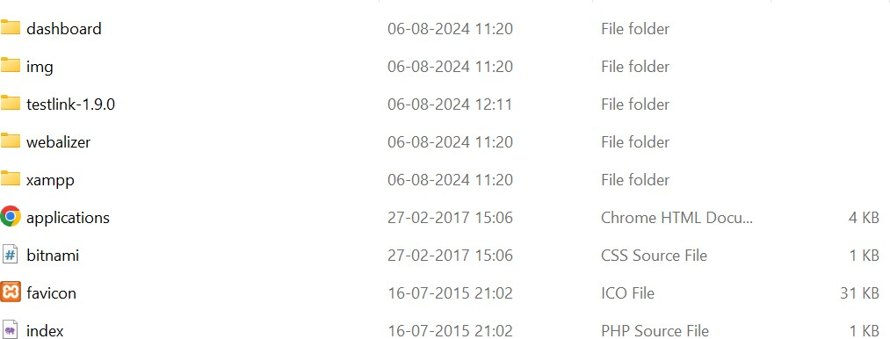Ans. Install testlink from <https://sourceforge.net/projects/testlink/> and extract the zip ﬁle at C:\xampp\htdocs\testlink-1.9.0.

1. Create a Database ‘testlink’.

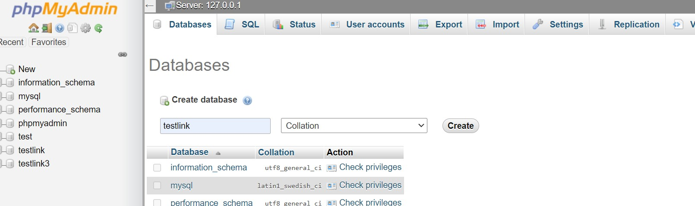

1. 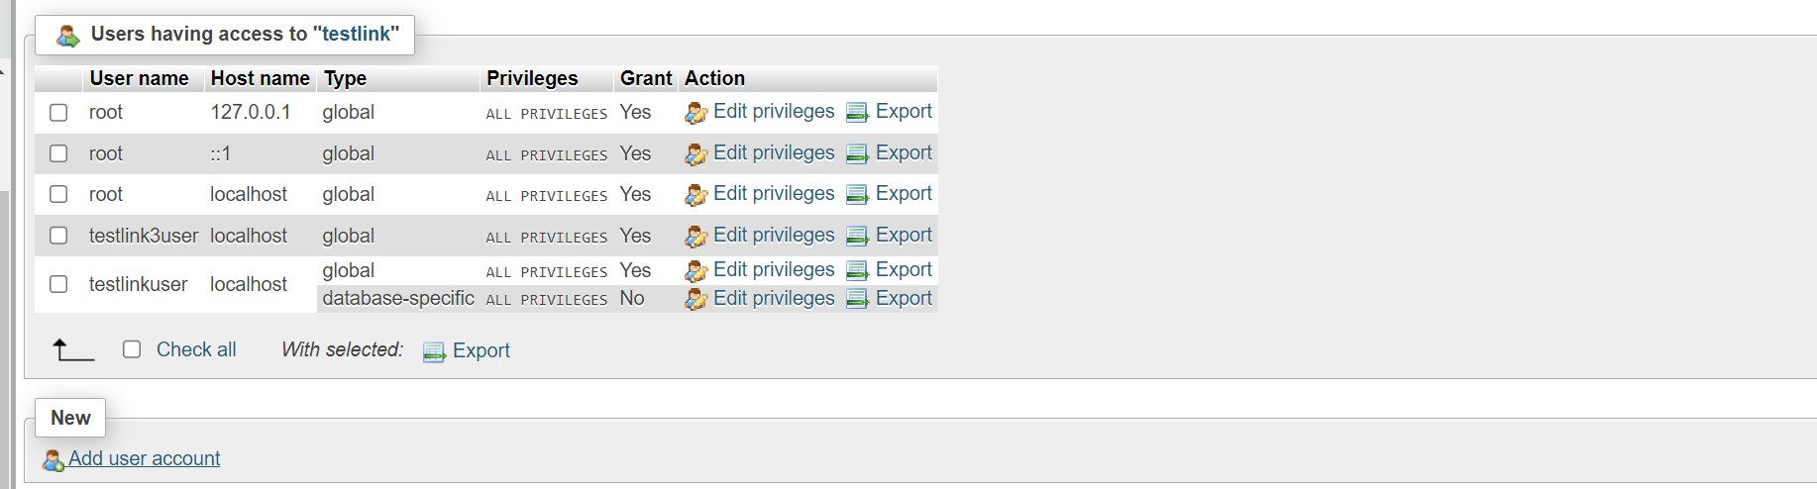Create a user named ‘testlinkuser’.
2. 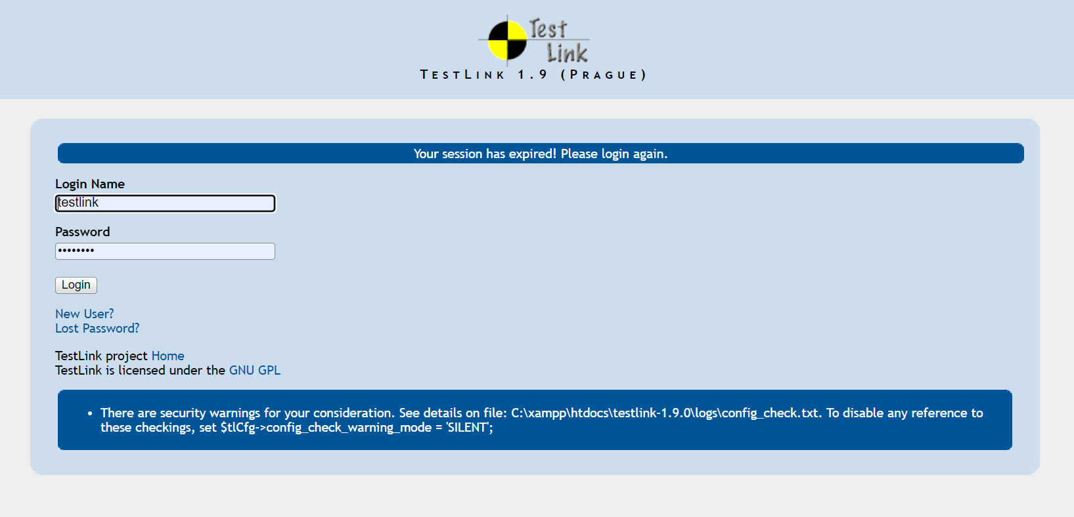Create a User In testlink.
3. 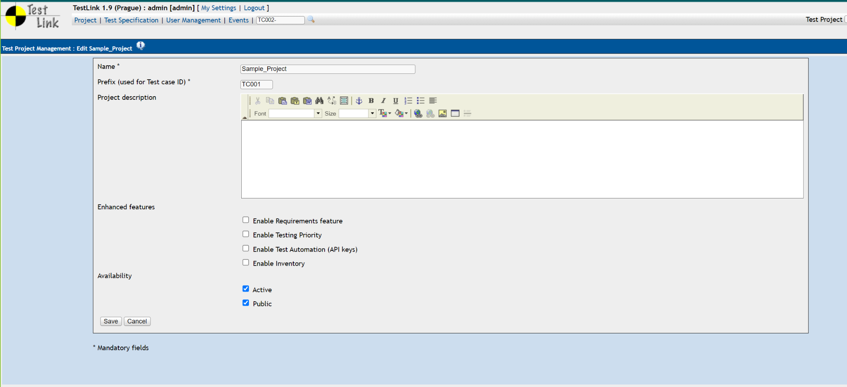Create a new project in TestLink, naming it "Sample Project."

# Task 2: Test Plan Creation

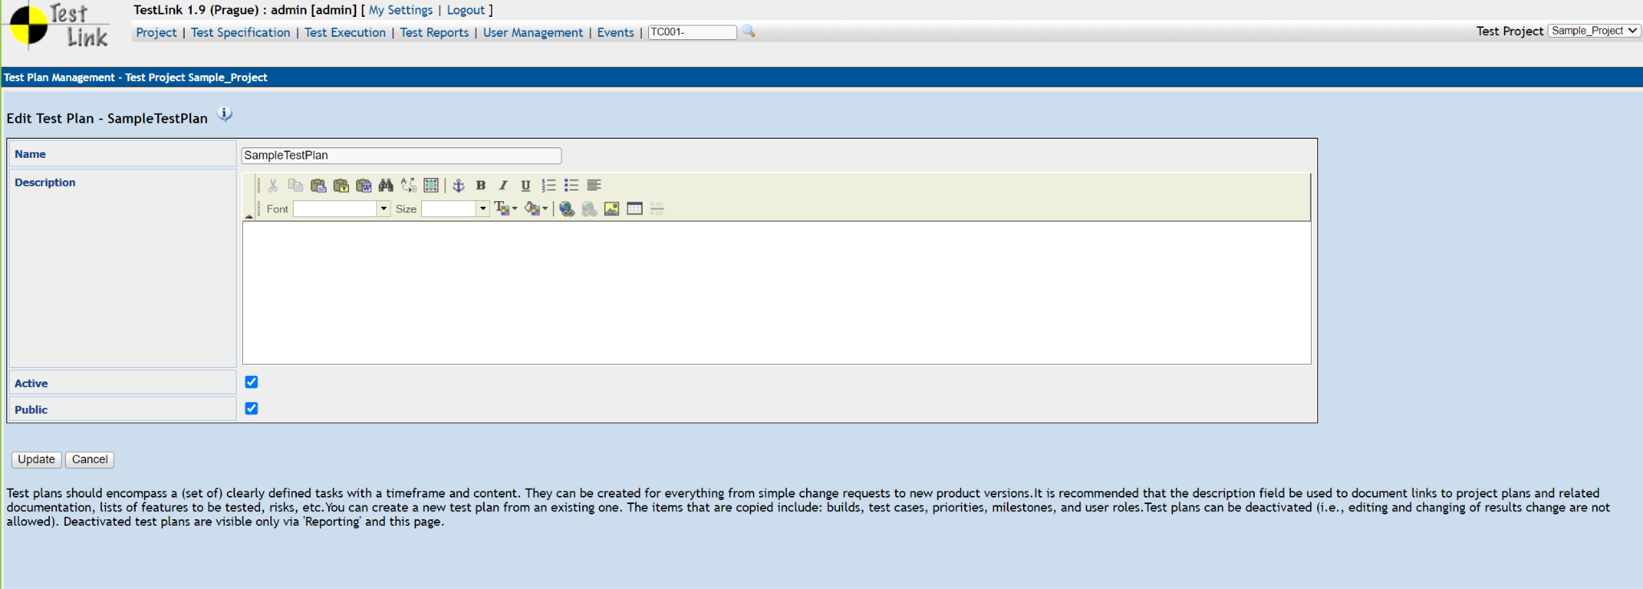1. Create a test plan for the Sample Project.

# Task 3: Test Suite Creation

1. Create at least two test suites within the test plan.
2. 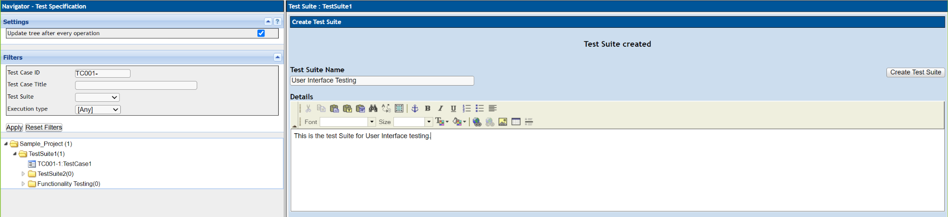Name the test suites "Functionality Testing" and "User Interface Testing.

# Task 4: Test Case Creation

1. 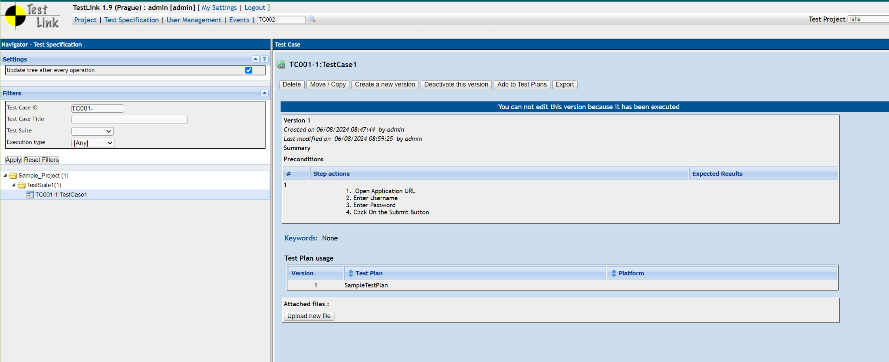Create test cases for each test suite with relevant test steps and expected results.
2. For the "Functionality Testing" suite, create test cases to cover di erent functionalities of the project.

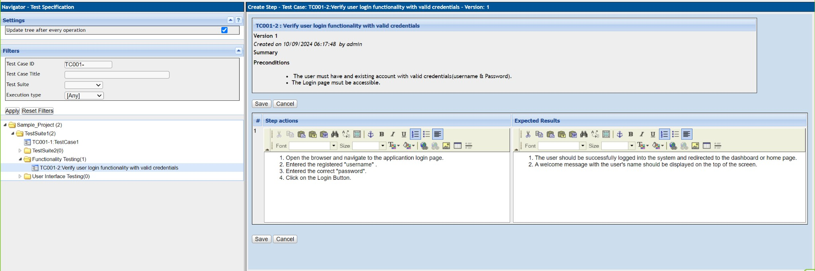

1. 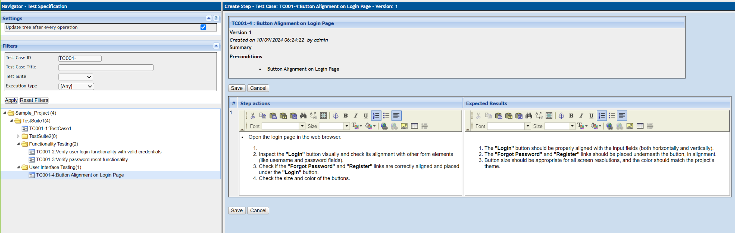For the "User Interface Testing" suite, create test cases to validate the project's user interface components.

# Task 5: Test Execution

1. 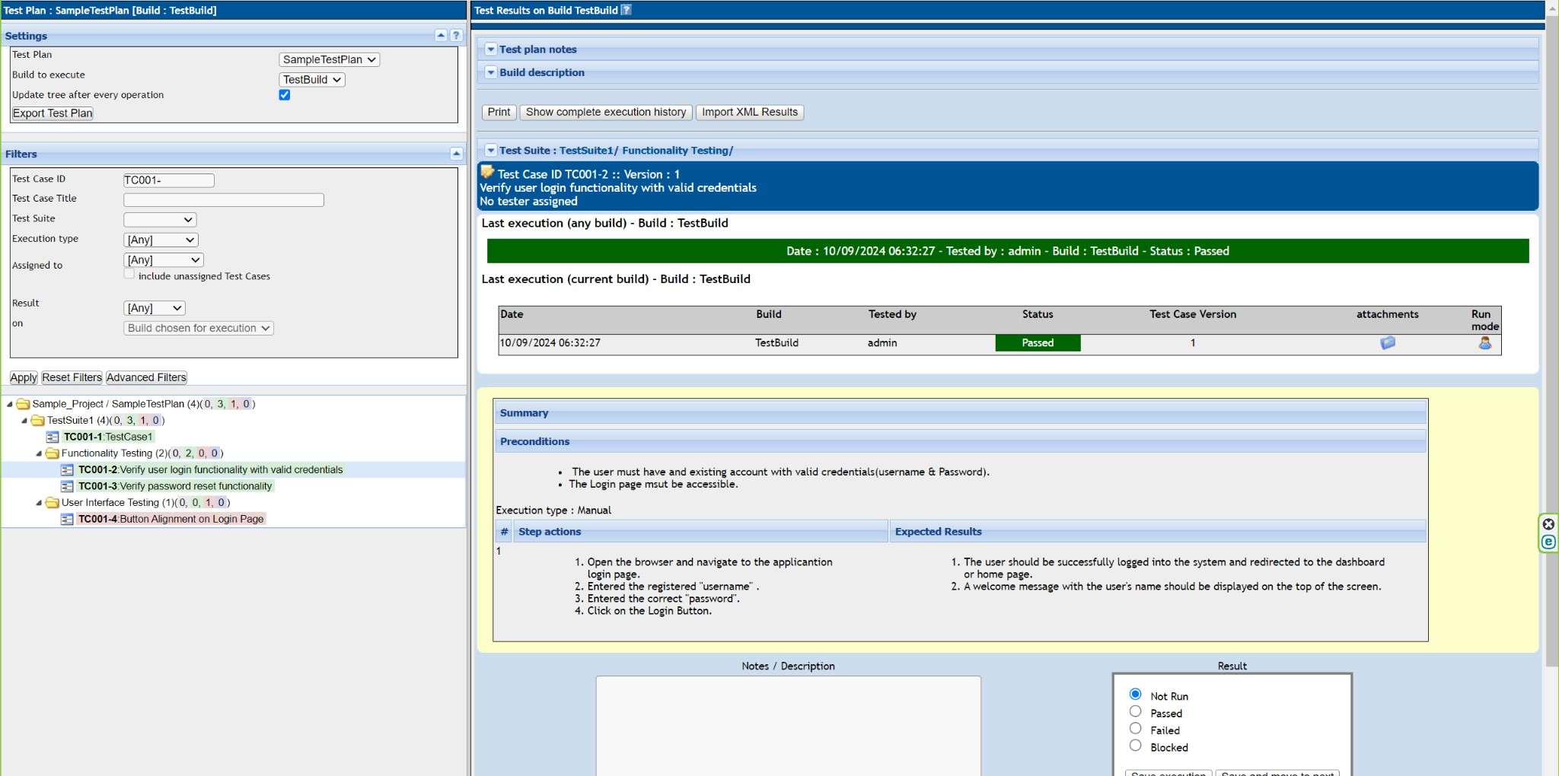Execute the test cases within the respective test suites.
2. Mark the test cases as "pass" or "fail" based on the test results.

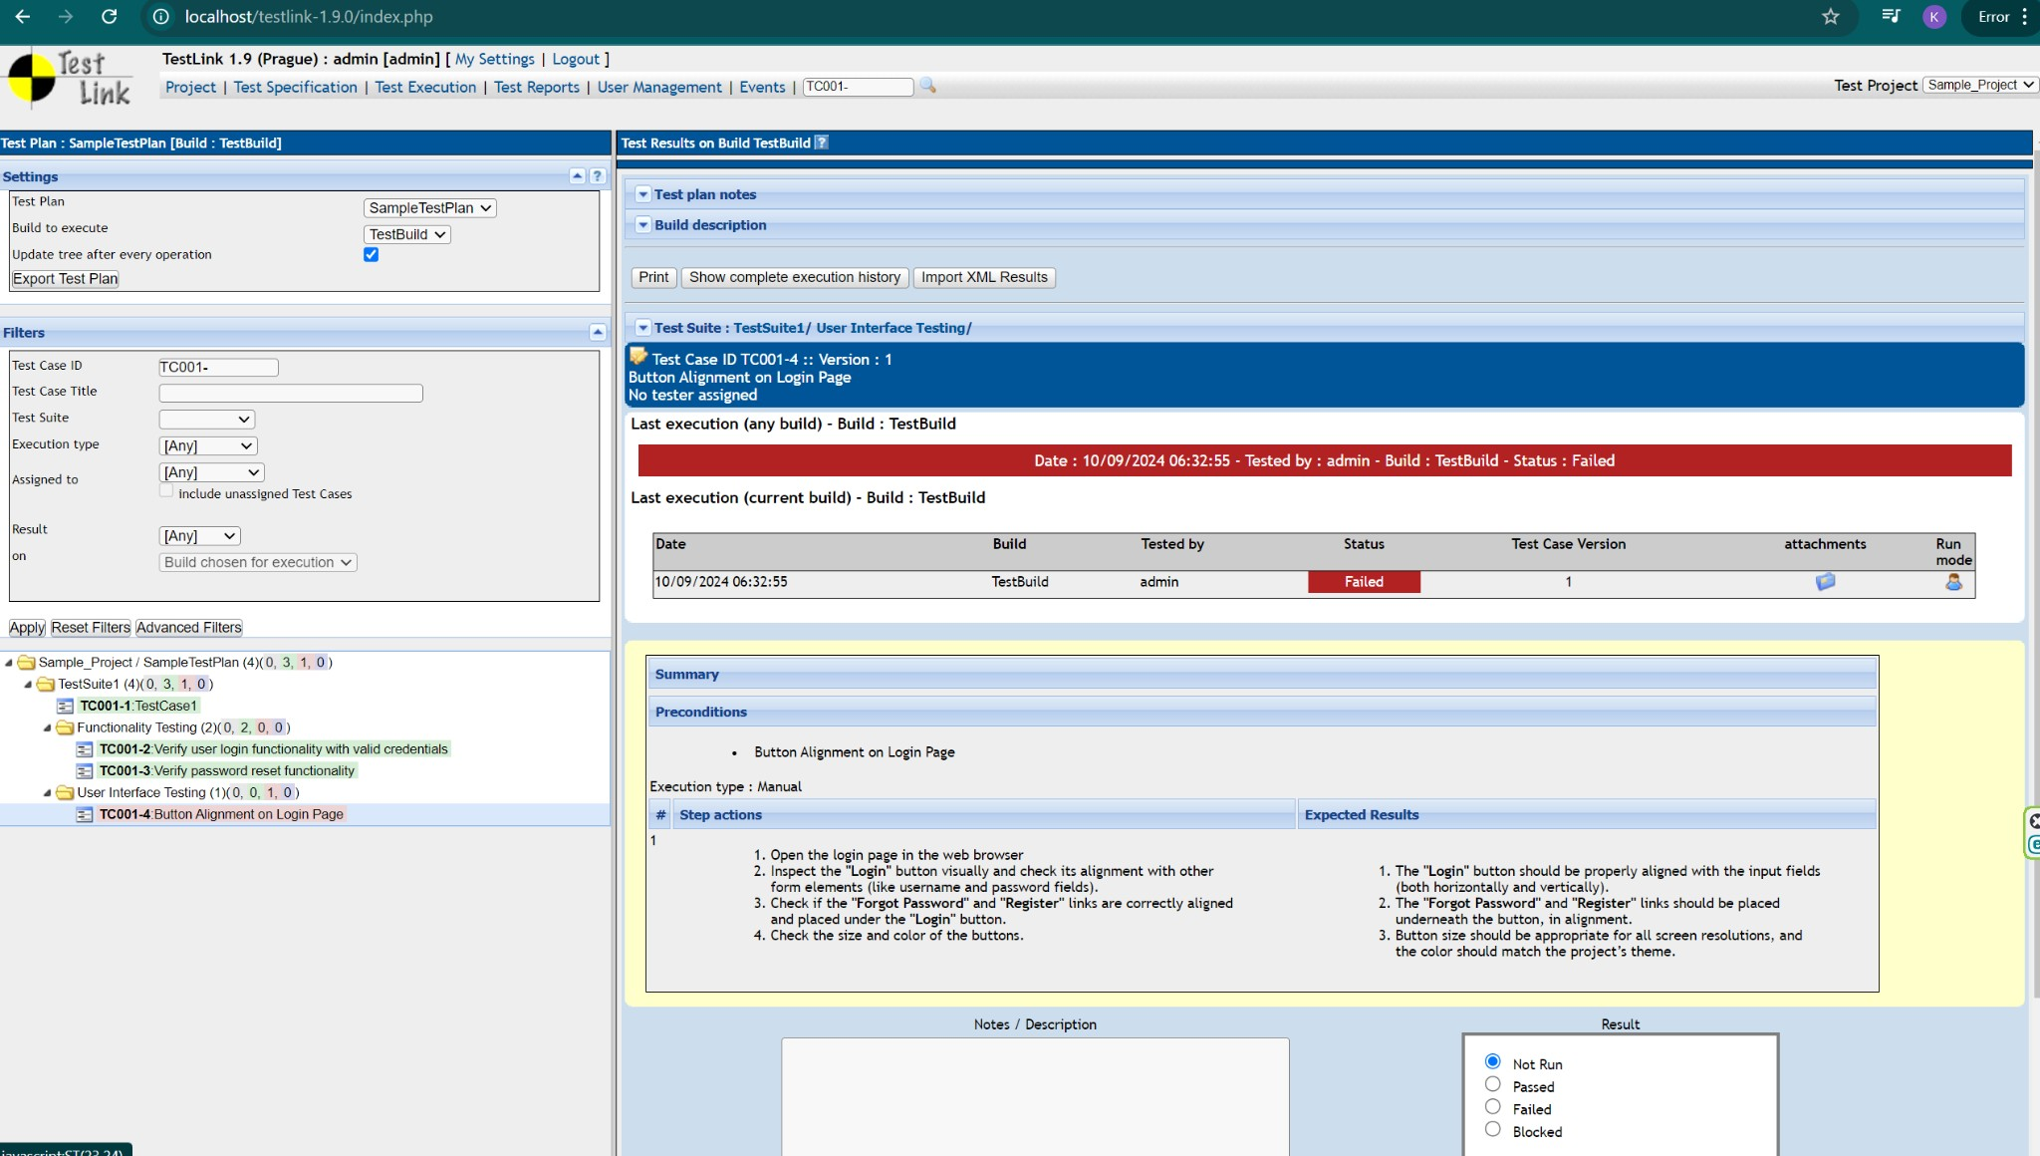

# Task 6: TestLink Reports

1. Generate a test execution report for the test plan.

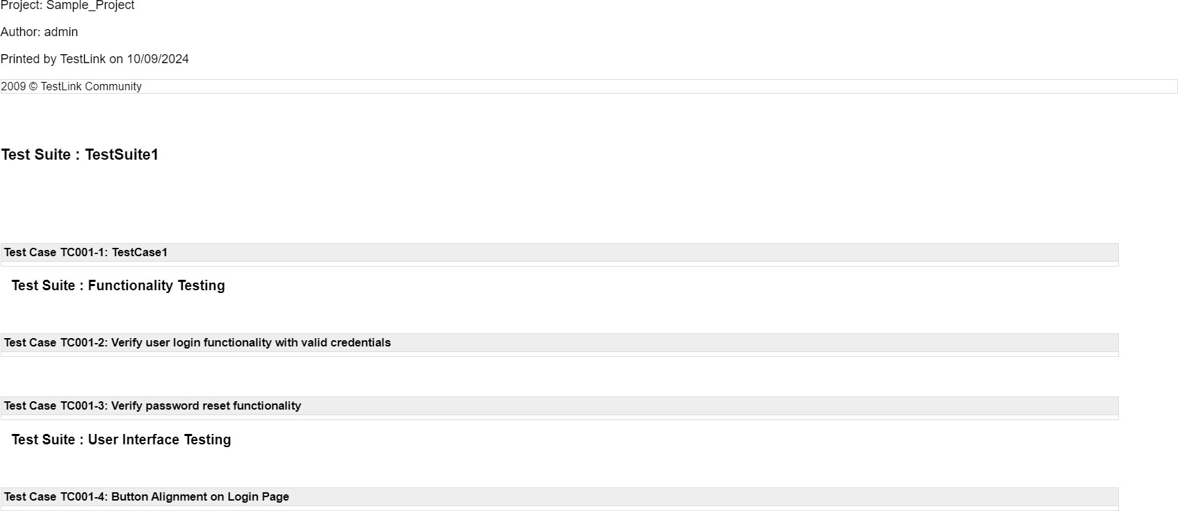

1. Include details of test cases executed